Project 1: Deploying a website on AWS EC2 instances.

1.Creating VPC

Steps:

1.In AWS console, search VPC.

2.In VPC dashboard, you will get my VPC’s and click on my vpc’s

3.Click on create VPC, Select resources to create as VPC only

4.Give name as prathi-vpc and IPv4 CIDR as 10.0.0.0/16

5.Then click on create VPC

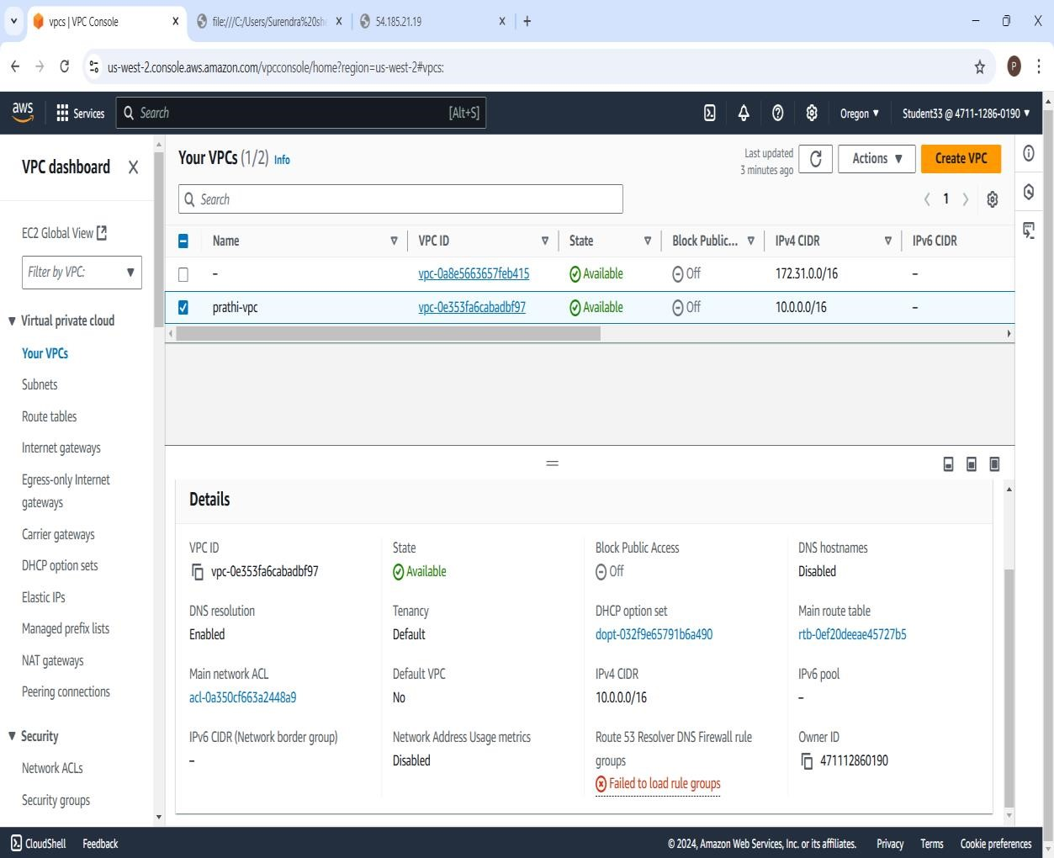

2.Create Internet Gateway :

Steps:

1.In VPC dashboard, click on Internet Gateway.

2.To create Internet Gateway, click on create Internet Gateway.

3.Then give name as prathi-igw and click on create Internet Gateway.

4.Your Internet Gateway is created.

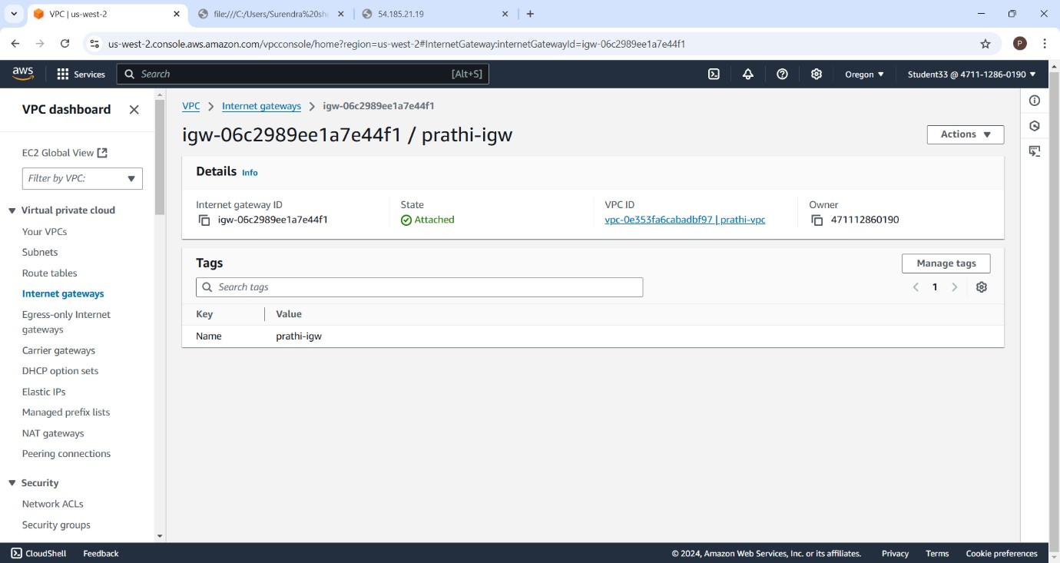

Public Subnet:

Steps:

1.To create subnet, go to VPC dashboard under virtual private cloud, click on subnet.

2.Select the vpc you have already created and in subnet setting, give subnet name as prathi-subnet1.

3.Then choose availability zone as region you have selected before creating the vpc and IPv4 subnet CIDR block as 10.0.1.0/25.

4.Then create one more subnet as following subnet but give name as prathi-subnet2 and then choose availability zone and IPv4 subnet CIDR block as 10.0.2.0/25

Public subnet 1:

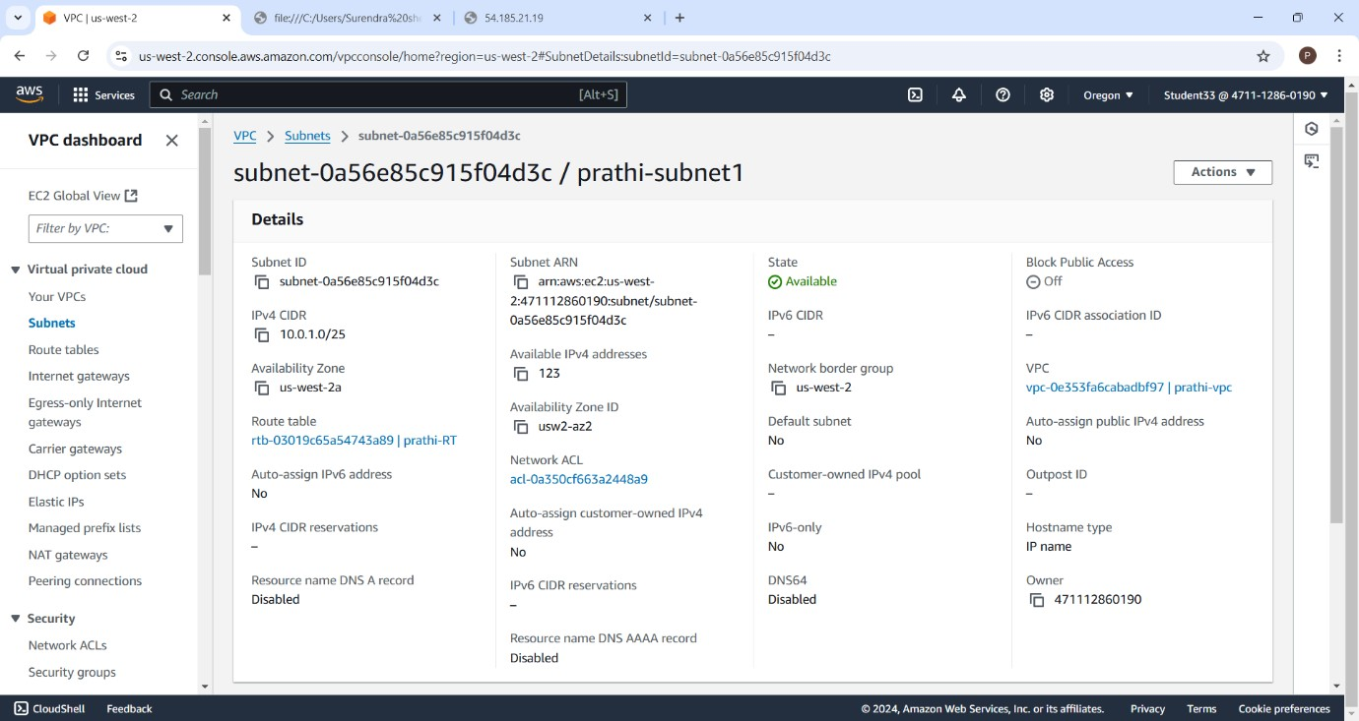

Public Subnet 2

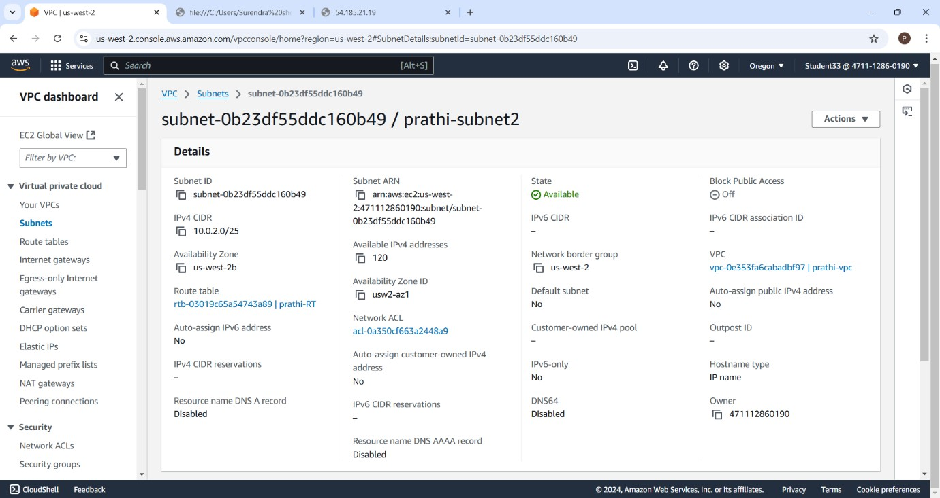

4.Create Route Table :

Steps:

1.To create Route Table, click on create route table.

2.In route table setting, give route table name as prathi-RT and select vpc that is created.

3.Then click on create route table.

4.After route table is created, go to routes and click on edit route and then click on add route.

5.Then in destination ,select 0.0.0.0/0 as destination and target as Internet Gateways.

6.After selecting internet gateway, it allows to select the igw and select the internet gateway that is created by you.

7.At last, click on save changes.

8.Then go to subnet association and click on edit subnet association.

9.Select the subnet you have created and click on save changes.

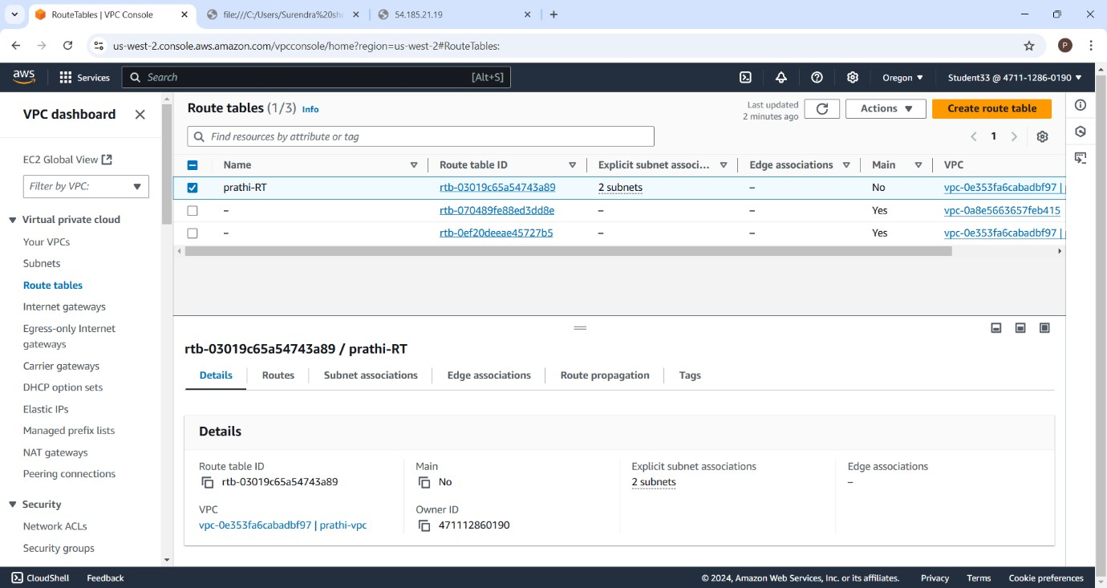

EC2 Instances:

Steps:

1.Go to EC2 in AWS console and click on instance.

2.Click on launch instances and give the name for the instances as prathi-server.

3.After giving name to instances, select application and OS images as Amazon Linux and instance type as t2.micro.

4.In keypair, click on create keypair and give keypair name as prathi-keypair and click on create keypair. The keypair is created.

5.Then in network setting, click edit. Select vpc and subnet and also assign public IP as enable.

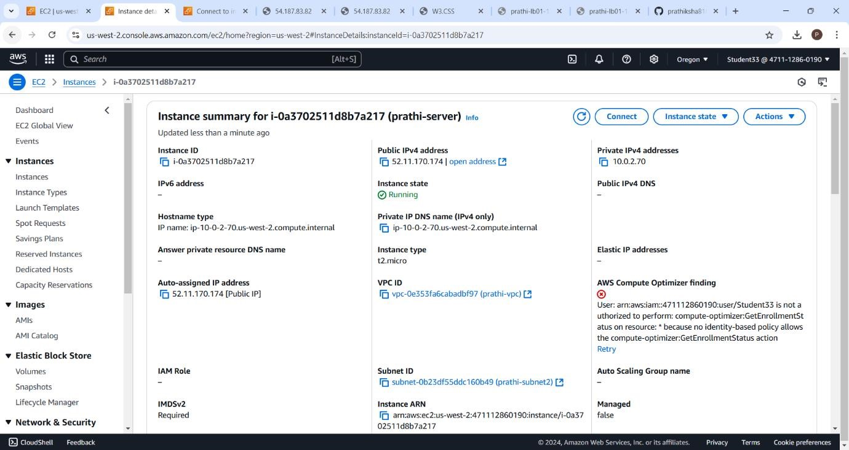

Connection :

Steps:

1.Select the instance you have created and click on create.

2.Go to SSH client. Copy the example.

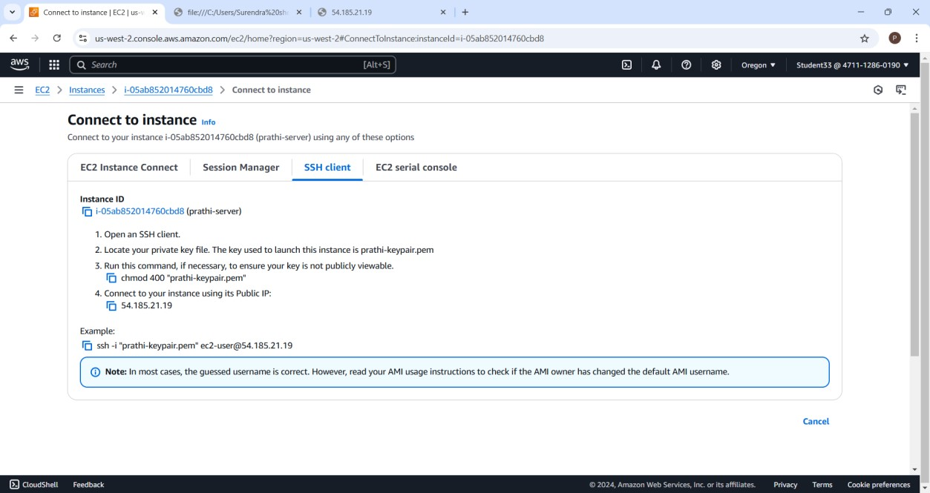

Command Prompt :

Steps:

1.Go to command prom pt and follow the following commands.

* Cd downloads.
* Paste the SSH client example.
* You will get to confirm the connecting ,you have type yes.
* Then type sudo su and cd.
* Then to install apache yo have to type yum install httpd -y.
* After installation,type cd /var/www/html.
* Then type vi index.html and vi editor is opened then press I to insert the content after that press esc

And :wq to save the content and quit.

* Go to instances, copy the public ip and paste on browser.

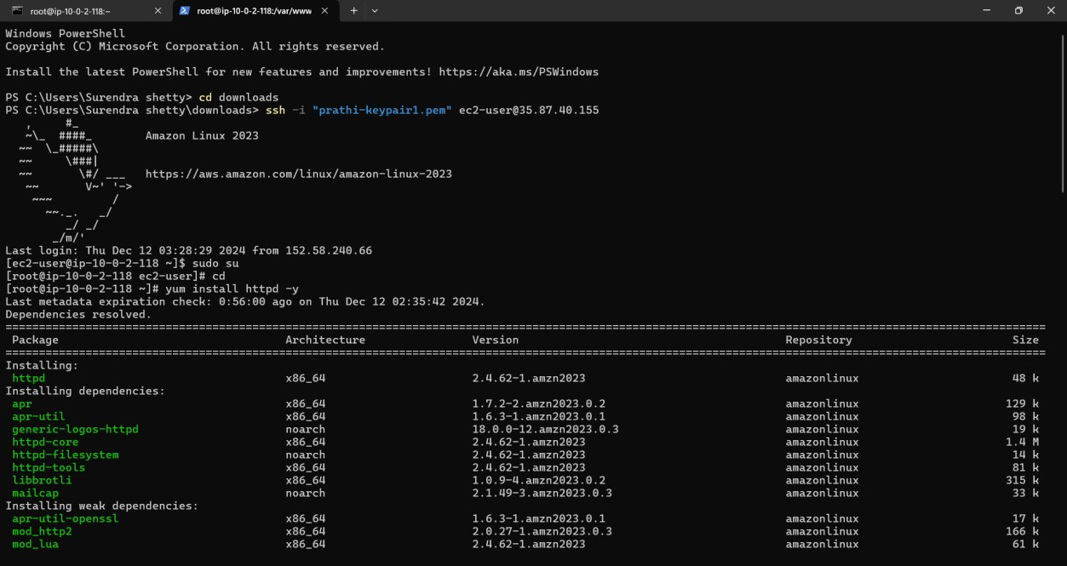

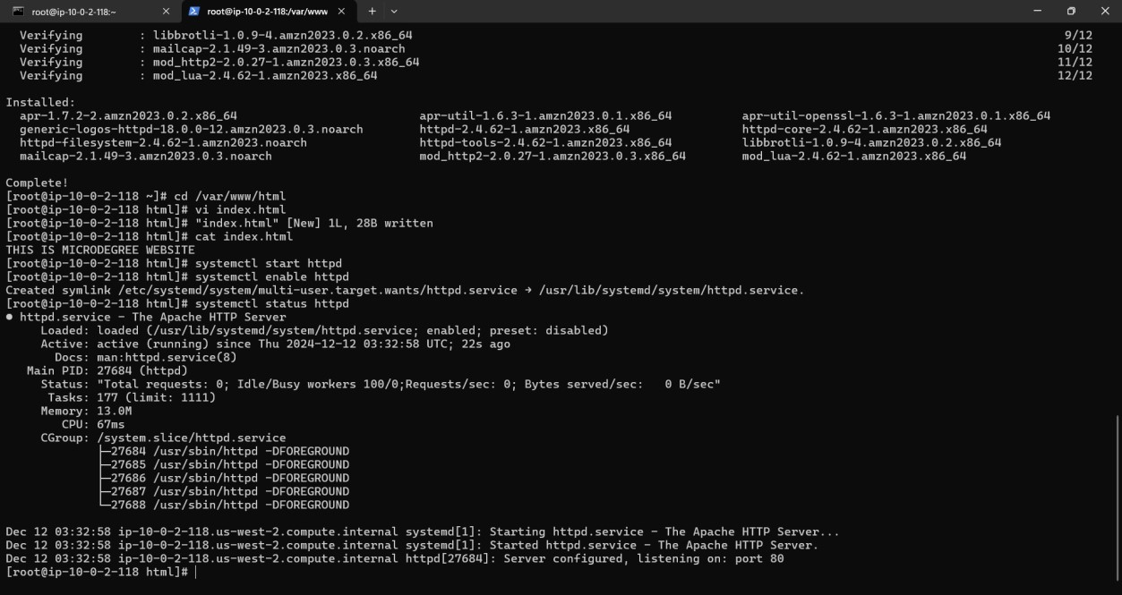

Final Output :

